Power Save - Deep Sleep Mode

Materials

* AmebaD [ [AMB23](https://www.amebaiot.com/amebad/#rtk_amb23) / [AMB21](https://www.amebaiot.com/amebad/#rtk_amb21) / [AMB22](https://www.amebaiot.com/amebad/#rtk_amb22) / [BW16](https://www.amebaiot.com/amebad/#partner_bw16) ] x 1

Example

**Introduction**

AmebaD supports 2 low power modes which are deep sleep mode and sleep mode. Deep Sleep mode turns off more power domain than sleep mode. The power consumptions of Deep Sleep mode is around 7μA to 8μA as compared to normal state which is around 22mA. This example describes how to enter Deep Sleep mode and configure the wakeup source.

**Procedure**  
Open “File” -> “Examples” -> “AmebaPowerSave” -> “DeepSleepMode”

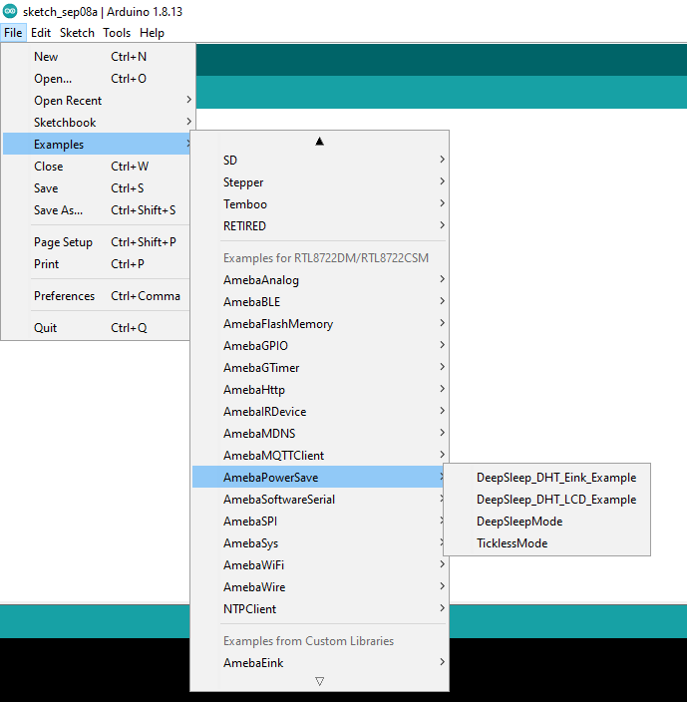

Set condition values as below.  
“DS_WAKEUP_SOURCE” is used to set the wakeup source, user can choose 3 wakeup sources,  
AON Timer (SET_DS_AON_TIMER_WAKEUP);  
AON GPIO pins (SET_AON_WAKEPIN_WAKEUP);  
RTC Timer(SET_DS_RTC_WAKEUP);

Using AON Timer as wakeup source

AON Timer can be set from 0 to 32760000ms range by AON_TIMER_SLEEP_DURATION.

Using AON GPIO pins as wake up source

For AMB21, there are 5 pins that can be set as AON pins and active high for wakeup, GPIOA25(D16), GPIOA26(D17), GPIOA21(D26), GPIOA20(D27), GPIOA(D28).

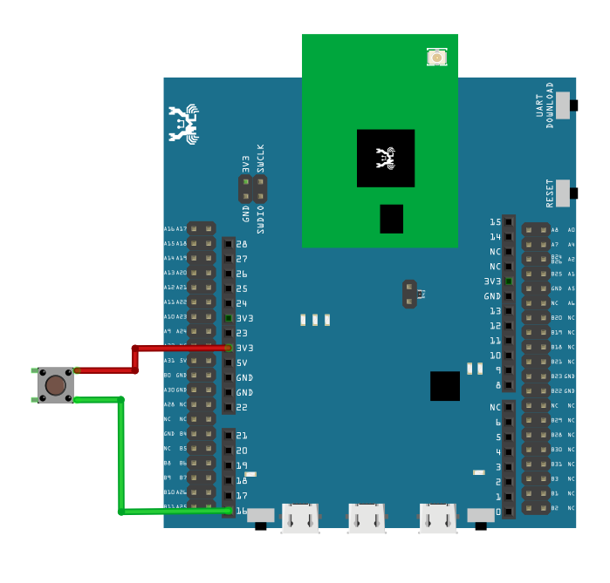

For AMB23, there are 8 pins that can be set as AON pins and active high for wakeup, GPIOA12(D9), GPIOA13(D10), GPIOA14(D11), GPIOA15(D12), GPIOA16(D13), GPIOA18(D15), GPIOA19(D16), GPIOA21(D18).

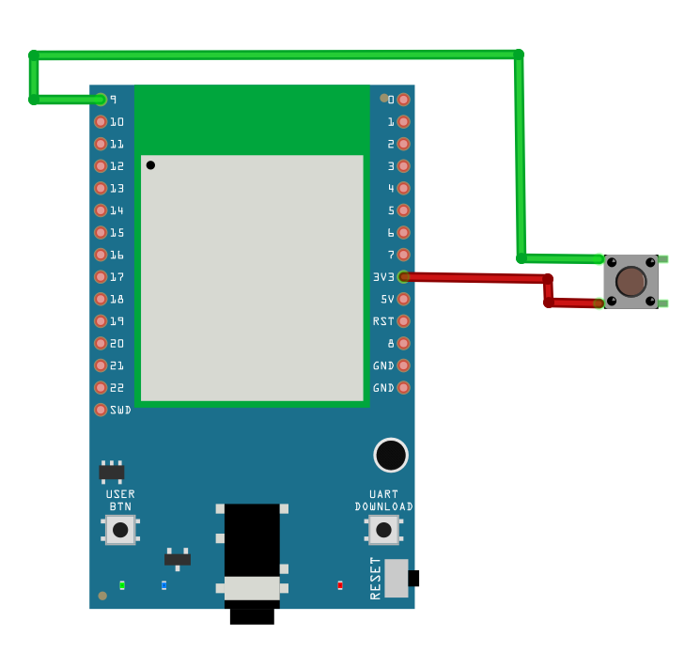

For BW16/BW16-TypeC, there is only 6 pins that can be set as AON pin and active high for wakeup, GPIOA_25 (D7), GPIOA_26 (D8), GPIOA_15 (D9), GPIOA_14 (D10), GPIOA_13 (D11), GPIOA_12 (D12).

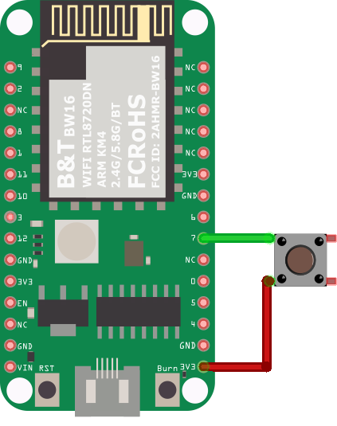

These AON pins can be set by using SET_AON_GPIO_WAKEUP_GPIOA25 or the pin that you want to use as shown in the picture below.

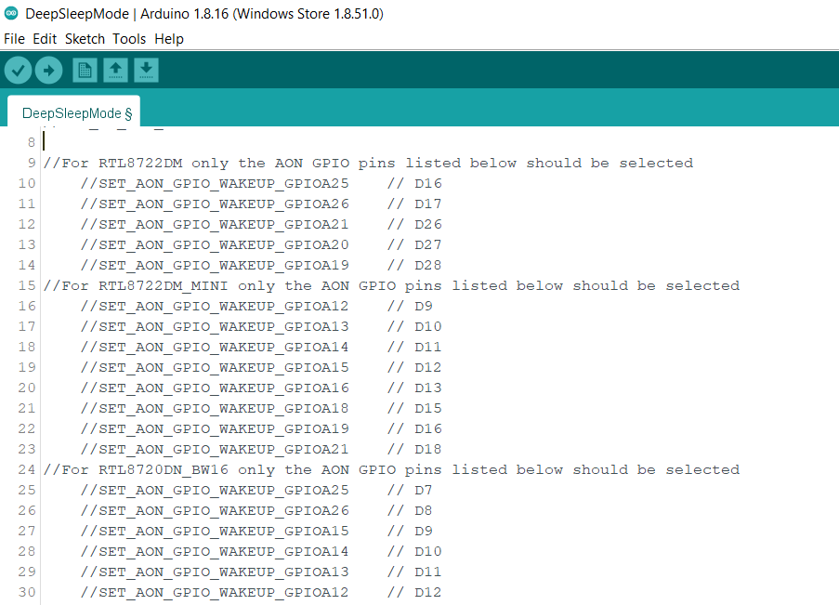

Using RTC Timer as wakeup source

RTC Timer wakeup system is by setting alarm. The alarm has 4 values to be set, day, hour, min and sec. All 4 values can be set by DS_RTC_ALARM_DAY, DS_RTC_ALARM_HOUR, DS_RTC_ALARM_MIN, and DS_RTC_ALARM_SEC.

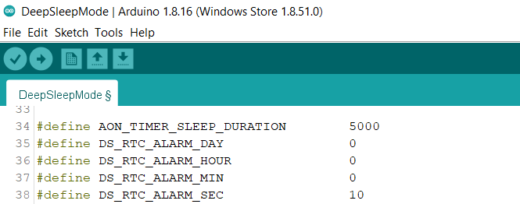

When all the condition values are set, the system will run and switch between normal and deep sleep mode which is controlled by the wakeup source. The serial monitor will display the switching log as shown below.

**AON Timer**

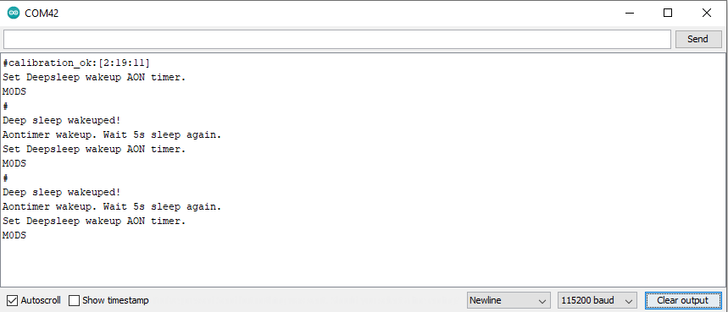

**AON GPIO Pin**

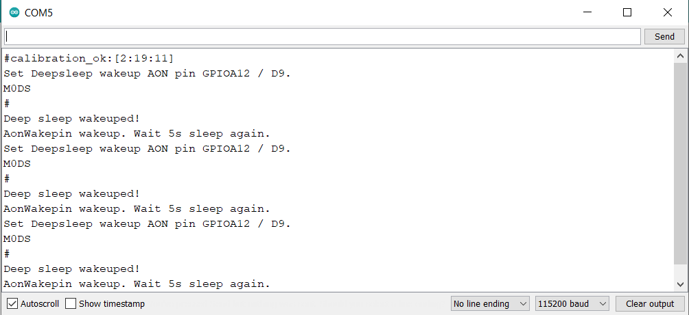

**RTC Timer**

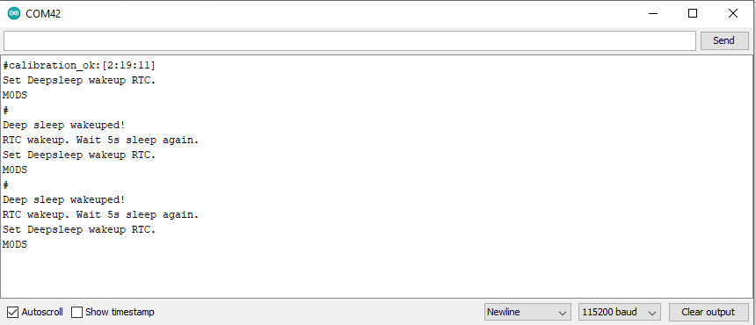

Code Reference

Please refer to the [API Documents](https://www.amebaiot.com/rtl8722dm-arduino-online-api-documents/) PowerSave section for detail description of all API.